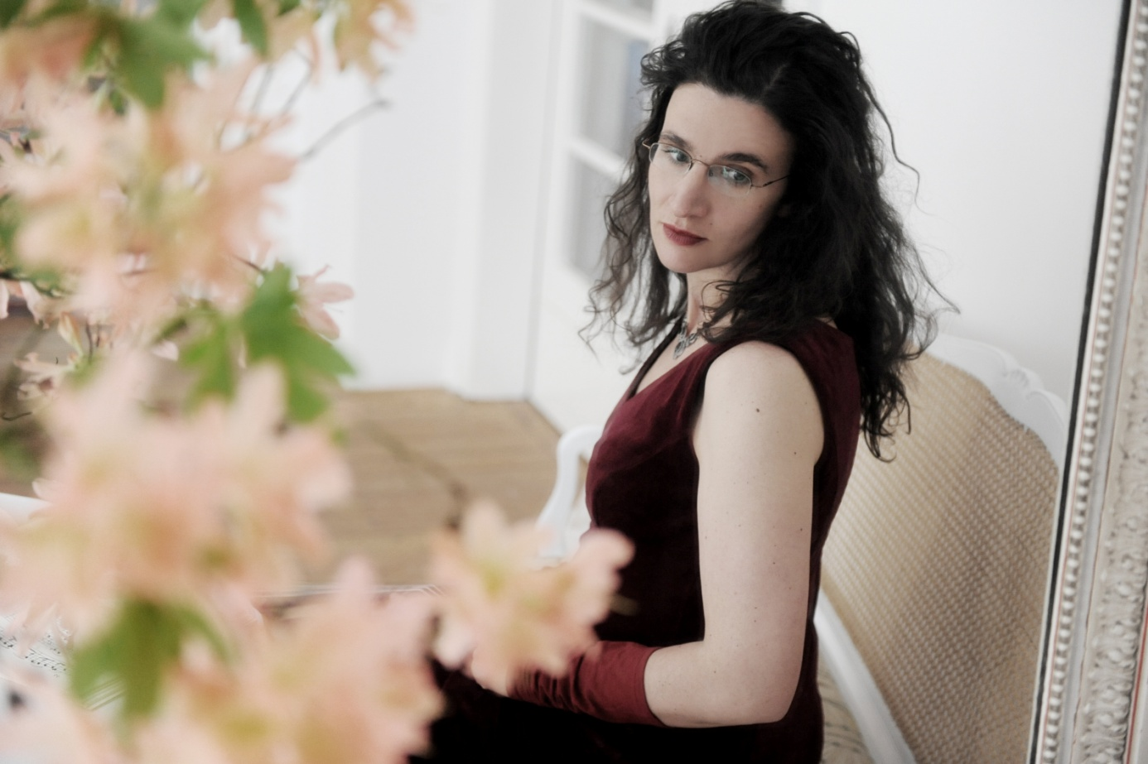
Juliane Laake - Ensemble Art d’Echo
Juliane Laake studied viola da gamba at the Hochschule für Musik, Bremen, and the Royal Conservatoire at Den Haag. She further enhanced her expertise at a number of master courses with internationally famous authorities. As holder of a Deutscher Musikrat scholarship and prize-winner at the International Telemann Competition Magdeburg, she has also become a natural choice for the Leipzig Bach Festival and other prestigious ancient music festivals. She has performed in various centres including Utrecht, Copenhagen, Stockholm, Zurich, Tel Aviv and Sydney, and works regularly with ensembles such as the Lautten Compagney, Weser-Renaissance, the Ensemble Polyharmonique and the Ancient Music Academy Berlin. She has performed with eminent soloists such as Hille Perl and Dorothee Mields and outstanding conductors including Hans-Christoph Rademann and Pablo Heras-Casado. Juliane Laake’s wide-ranging discography bears witness to these successful collaborations. In her own concert programmes and CD productions, accompanied by her Art d'Echo Ensemble, Juliane Laake devotes herself to gamba literature in all its facets, with special emphasis on more rarely heard pieces. Her ambitious research work, together with her highly virtuosic and expressive performance style, speak for themselves in her numerous world first recordings, highly praised in the press. Her CDs have several times been nominated for the German Record Critics’ prize, the International Classical Music Award (ICMA) and the OPUS Klassik award.
The Art d'Echo Ensemble was found in 2010 by the gambist Juliane Laake. Since that time she has been pursuing her own musical projects with this ensemble in varying instrumental combinations. The musicians chosen by her for this purpose, all of them specialists in their own fields, have been enriching her work with their considerable musical inspiration and their profound practical expertise. Central to this is the remarkably varied literature for viola da gamba, spotlighted by her ambitious programming. The ensemble’s success is documented in numerous CDs, broadcast recordings, and appearances in concerts and festivals. They have also been nominated for several prizes.

